Name = Mohmadniwal Gavandi

Sr. NO. = 45

Q1. Wap to convert Fahrenheit to Celsius  in Java using formula given below  
  
  °C = (°F – 32) / (9/5)

**import** java.util.Scanner;

**public** **class** Q1 {

**public** **static** **void** main(String[] args)

{

Scanner s=**new** Scanner(System.***in***);

System.***out***.println("Enter temp in feren");

**double** f=s.nextDouble();

System.***out***.println("The temp in feren is : " + f);

**double** c=((5*(f-32.0))/9.0);

System.***out***.println("The Temperature is in Centigrate :" + c);

}

}

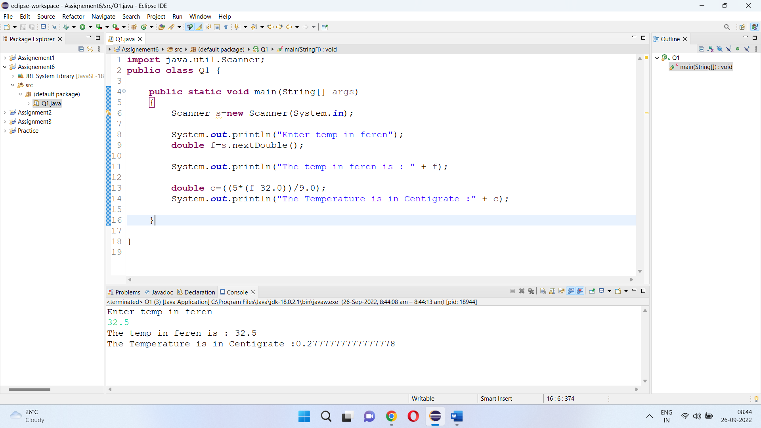

Q2. wap to check a given number is armstrong or not  i.e. 153 = 1*1*1  + 5*5*5+3*3*3

**import** java.util.Scanner;

**public** **class** Q2 {

**public** **static** **void** main(String[] args)

{

Scanner s=**new** Scanner(System.***in***);

System.***out***.println("Enter the number");

**int** num=s.nextInt();

**int** num1=num/10;

**int** a=num1/10;

**int** b=num1%10;

**int** c=num%10;

**if**(((a*a*a)+(b*b*b)+(c*c*c))==(num))

{

System.***out***.println("The number is armstrong number");

}

**else**

{

System.***out***.println("The number is not armstrong number");

}

}

}

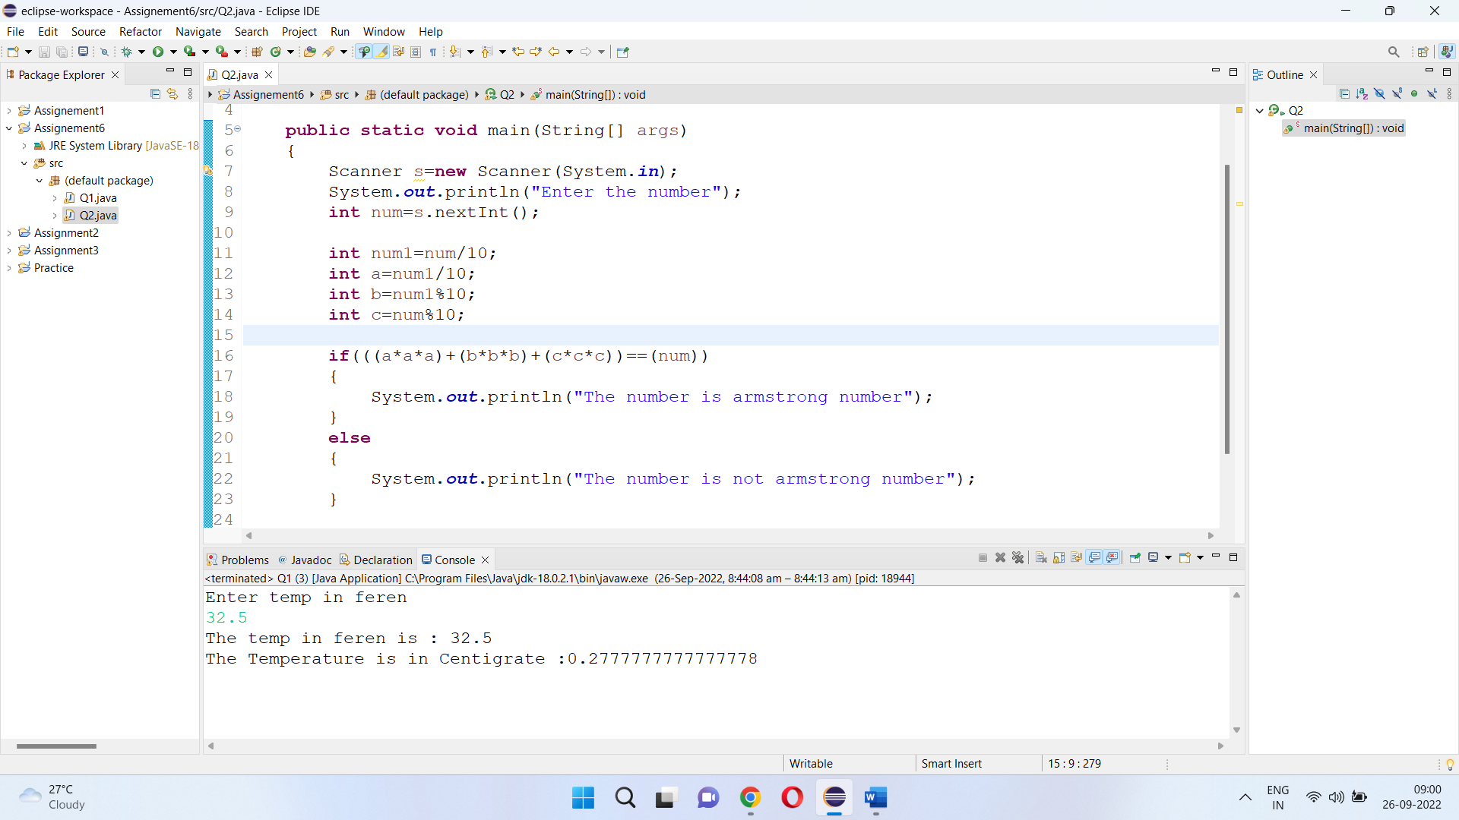

Q3. Rajan  went to a movie with his friends in a multiplex theatre and during  break time he bought pizzas, puffs and cool drinks. Consider   the following prices :

Rs.100/pizza  
Rs.20/puffs  
Rs.10/cooldrink  
Generate a bill for What Rajan  has bought.

Sample Input 1:  
  
Enter the no of pizzas bought:10  
Enter the no of puffs bought:12  
Enter the no of cool drinks bought:5  
  
Sample Output 1:  
  
Bill Details  
No of pizzas:10  
No of puffs:12  
No of cooldrinks:5  
Total price=1290

**import** java.util.Scanner;

**public** **class** Q3a {

**public** **static** **void** main(String[] args)

{

Scanner s=**new** Scanner(System.***in***);

System.***out***.println("Enter nu8mber of Pizza");

**int** p=s.nextInt();

System.***out***.println("Enter nu8mber of Puff");

**int** pf=s.nextInt();

System.***out***.println("Enter nu8mber of Cold Drink");

**int** c=s.nextInt();

System.***out***.println("The cost of Pizza is:" + p*100);

System.***out***.println("The cost of Puff is:" + pf*20);

System.***out***.println("The cost of Cold Drink is:" + c*10);

**int** total=((p*100)+(pf*20)+(c*10));

System.***out***.println("The total amout of paid is:" + total);

}

}

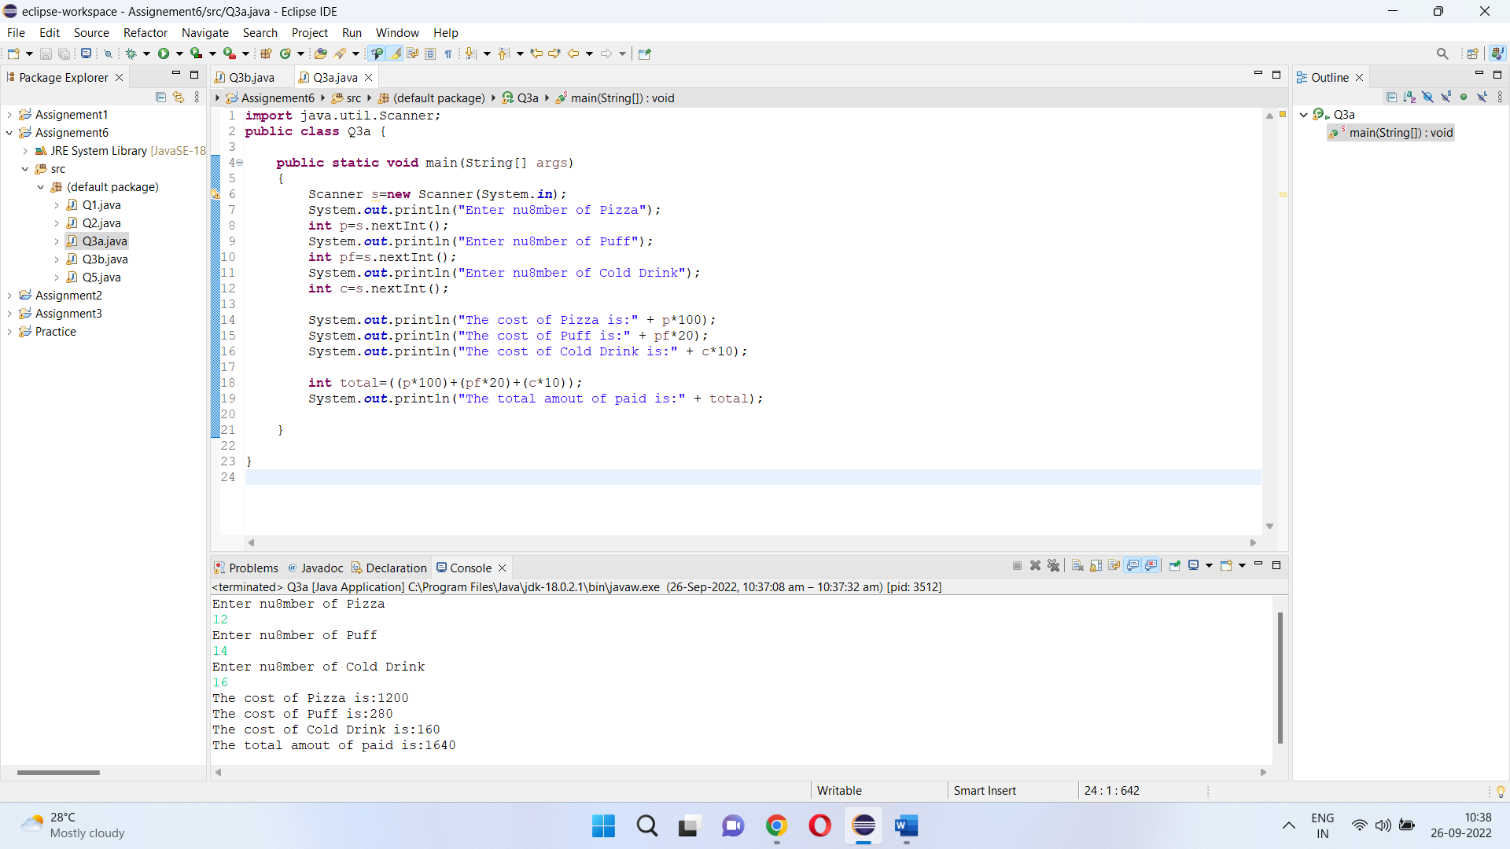

Q3.  Given an integer U denoting the amount of KWh units of electricity consumed, the task is to calculate the electricity bill with the help of the below charges:  
   
  
1 to 100 units – Rs. 10/unit  
100 to 200 units – Rs. 15/unit  
200 to 300 units – Rs. 20/unit  
above 300 units – Rs. 25/unit  
Examples:  
   
  
Input: U = 250  
Output: 3500  
Explanation:  
Charge for the first 100 units – 10*100 = 1000  
Charge for the 100 to 200 units – 15*100 = 1500  
Charge for the 200 to 250 units – 20*50 = 1000  
Total Electricity Bill = 1000 + 1500 + 1000 = 3500  
Input: U = 95  
Output: 950  
Explanation:  
Charge for the first 100 units – 10*95 = 950  
Total Electricity Bill = 950

**import** java.util.Scanner;

**public** **class** Q4 {

**public** **static** **void** main(String[] args)

{

Scanner s= **new** Scanner(System.***in***);

System.***out***.println("Enter units consumed in Kwh");

**double** unit=s.nextDouble();

System.***out***.println("Electricity bill");

**if**((unit>=1) && (unit<=100))

{

System.***out***.println("The bill of electricity is : " + unit*10);

}

**else** **if**((unit>100) && (unit<200))

{

System.***out***.println("The bill of electricity is : " + unit*15);

}

**else** **if**((unit>200) && (unit<300))

{

System.***out***.println("The bill of electricity is : " + unit*20);

}

}

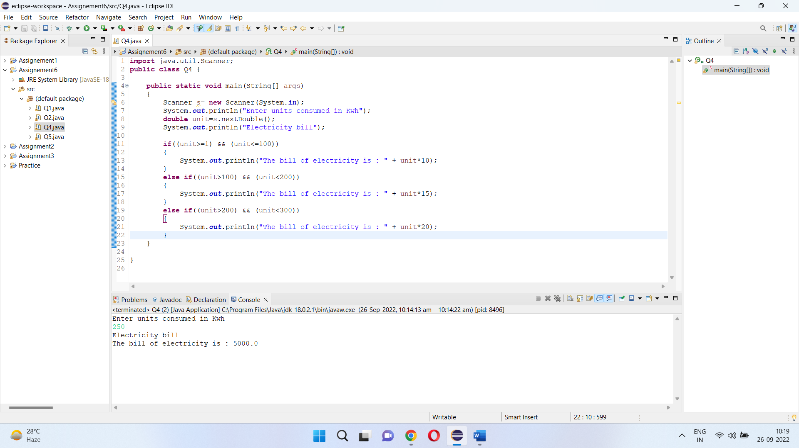

Q4. Write a java program that  define a sorted array of size N and an integer K, find the position at which K is  
  
present in the array using binary search.  
  
Example 1:  
  
Input:  
N = 5  
arr[] = {1 2 3 4 5}  
K = 4  
Output: 3  
Explanation: 4 appears at index 3.

Q5.  write a java program and define  an array, print all the elements which are leaders. A Leader is an element that is greater than all of the elements on its right side in the array.  
  
Examples:  
  
Example 1:  
Input:  
 arr = [4, 7, 1, 0]  
Output:  
 7 1 0  
Explanation:  
 Rightmost element is always a leader. 7 and 1 are greater than the elements in their right side.

**import** java.util.Scanner;

**public** **class** Q3 {

**public** **static** **void** main(String[] args)

{

Scanner s=**new** Scanner(System.***in***);

System.***out***.println("Enter size of array: ");

**int** N=s.nextInt();

**int** a[]= **new** **int**[N];

System.***out***.println("Enter value in array: ");

**for**(**int** i=0; i<N ; i++)

{

a[i]=s.nextInt();

}

System.***out***.println("Leaders of array are: ");

**for** (**int** i=0; i<N ; i++)

{

**int** j;

**for**(j= i + 1; j < N; j++)

{

**if** (a[i] <= a[j])

**break**;

}

**if**(j == N)

System.***out***.println(a[i] + " ");

}

}

}

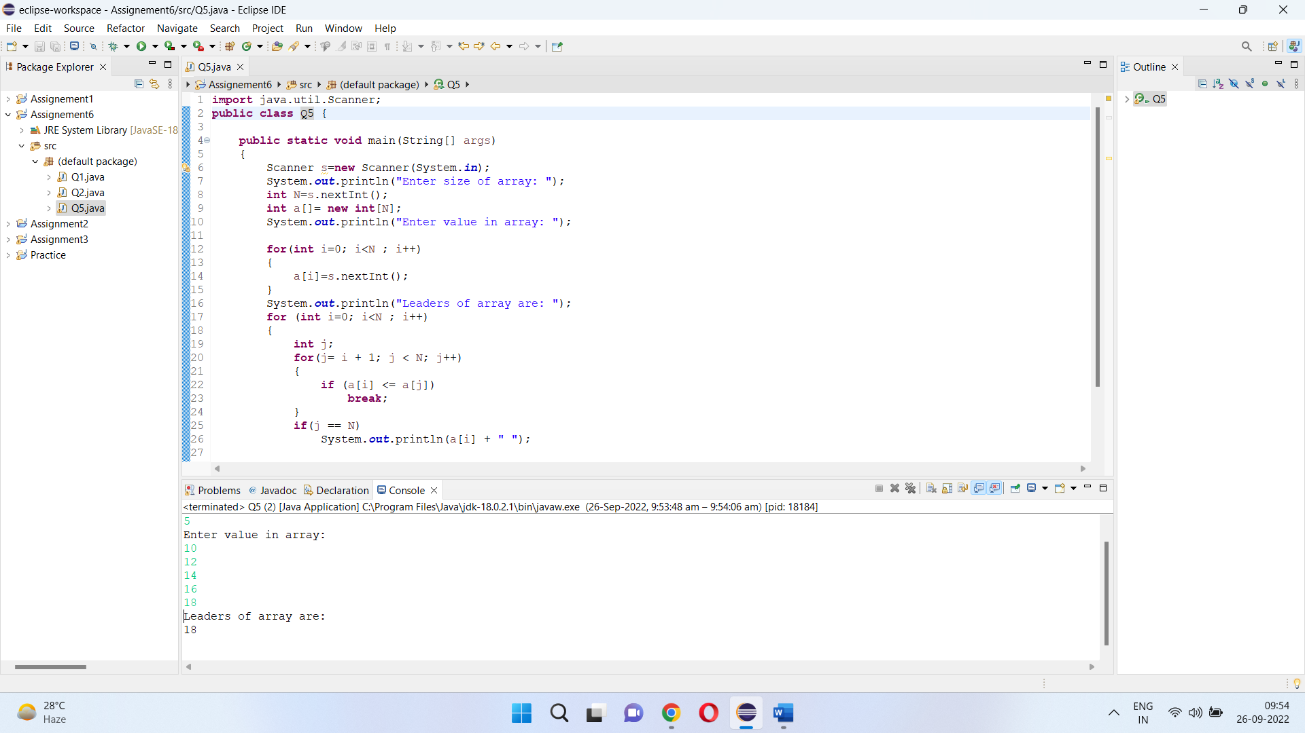

Q6. Given two strings a and b consisting of lowercase characters. The task is to check whether two given strings are an anagram of each other or not. An anagram of a string is another string that contains the same characters, only the order of characters can be different. For example,  abc  and  bca are an anagram of each other.  
  
Example 1:  
  
Input:a = cdacnoida, b = ciddacnoa  
Output: YES  
Explanation: Both the string have same characters with  
        same frequency. So, both are anagrams.